Mohammad Wildan Abiliansyah

R1

210511022

TUGAS PRAKTIKUM 3

Overload 1 :

'''

Nama : Mohammad wildan Abiliansyah

Kelas : R1

NIM : 210511022

Overload1

'''

class Math:

    def add(self, a, b=None, c=None):

        if b is not None and c is not None:

            return a + b + c

        elif b is not None:

            return a + b

        else:

            return a

m = Math()

print(m.add(7))

print(m.add(9, 3))

print(m.add(8, 3, 7))

Hasil Running program :

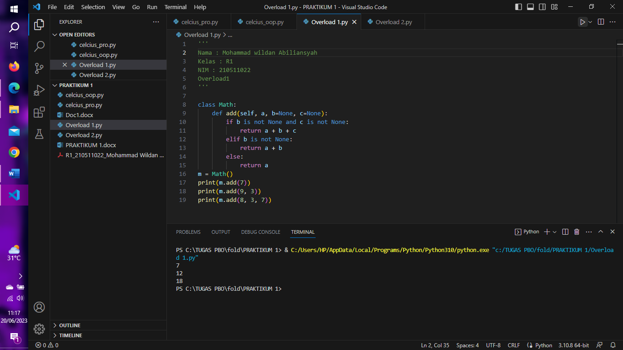

Overload 2 :

'''

Nama : Mohammad Wildan Abiliansyah

Kelas : R1

NIM : 210511022

Overload2

'''

class Math:

    def add(self, *args):

        total = 0

        for arg in args:

            total += arg

            return total

m = Math()

print(m.add(9))

print(m.add(50, 3))

print(m.add(8, 4, 16))

Hasil Running Program :

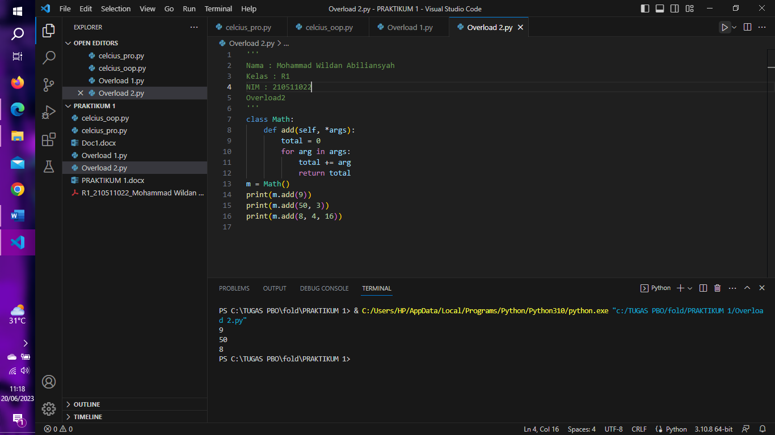

Overriding 1 :

'''

Nama : Mohammad Wildan Abiliansyah

Kelas : R1

NIM : 210511022

Overriding1

'''

class Pekerja:

    def __init__(self, name):

        self.name = name

    def gaji(self):

        raise NotImplementedError

class Supervisor(Pekerja):

    def gaji(self):

        return ' Rp 4.000.000'

class Manajer(Pekerja):

    def gaji(self):

        return ' Rp 6.000.000'

class Mekanik(Pekerja):

    def gaji(self):

        return ' Rp 3.500.000'

parapekerja = [Supervisor('Adinda'), Manajer('Ramandhika'),

Supervisor('Dwi'),Mekanik('Aru')]

for pekerja in parapekerja:

    print(pekerja.name + ': ','Gaji/bulan' + pekerja.gaji())

Hasil Running Program :

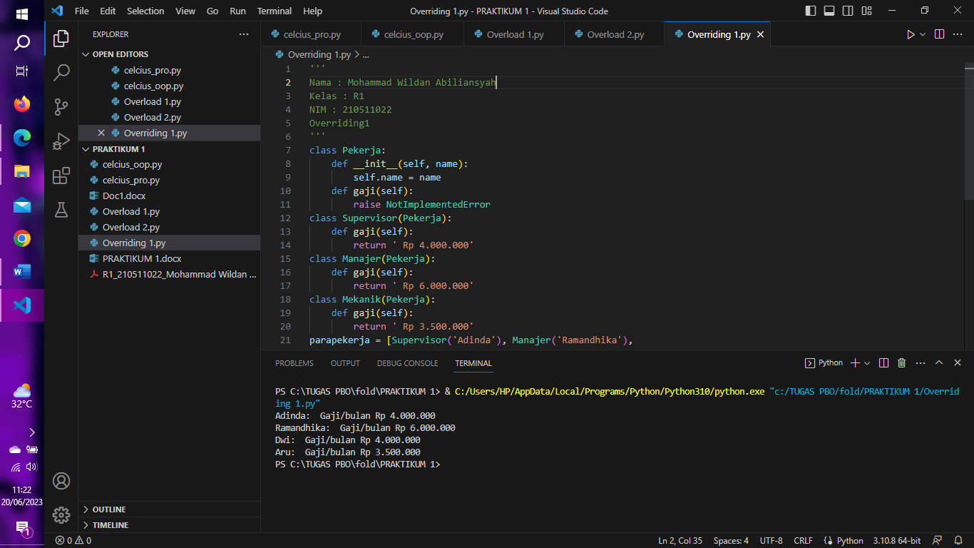

Overriding 2 :

'''

Nama : Mohammad Wildan Abiliansyah

Kelas : R1

NIM : 210511022

Overriding2

'''

class Pemain :

    def __init__(self, name):

        self.name = name

    def gaji(self):

        raise NotImplementedError

class Striker(Pemain):

    def gaji(self):

        return ' pencetak gol'

class Kiper(Pemain):

    def gaji(self):

        return ' penjaga gawang'

class Bek(Pemain):

    def gaji(self):

        return ' penjegal pemain lawan'

class Sayap(Pemain):

    def gaji(self):

        return ' pengumpan striker'

class Kapten(Pemain):

    def gaji(self):

        return ' Pemimpiin Tim'

class Wasit(Pemain):

    def gaji(self):

        return ' Memimpin Pertandingan'

Pemain = [Striker('Ronaldo'), Kiper('Andritany'), Bek('Ronaldinho'),

Sayap('Modic')]

for Pemain in Pemain:

    print(Pemain.name + ': ','Jalur' + Pemain.gaji())

Hasil Running Program :